# **Spacing & Type Size in Typography**

In this lesson, we'll explore the importance of space and size in typography. Find out how a font size is really measured, and learn the different kinds of spacing used, such as character spacing, line spacing, and word spacing.

## **The Importance of Space and Size**

**Typesetting** is a subset of typography, and in graphic design, it deals with the arrangement, and style of characters, in a larger body of writing where space plays a vital role. Have you ever wondered what the font size number means, other than larger numbers result in bigger letters? Have you ever found yourself distracted while reading a newspaper article before the words are spaced strangely on some lines, causing large gaps in the middle of the paragraph? Well, you have come to the right place, because we're going to answer those questions and more.

## **Font Size**

First, let's address the pesky question of font sizes and where they come from. You've likely noticed that two different fonts will have very different size letters, even when you select the same font size. That's because the size of a font is not actually the measurement of the size of the letters.

This all goes back in history to a time before the computer. Back then, people used printing presses to create uniform copies of documents like books and newspapers. Someone would arrange little blocks with raised, backward letters in a tray, to spell out the whole page of text. Think about that next time you complain about having to write a long paper!

Well, these blocks had to be the exact same height in order to fit together on a straight line. What we call font size is actually the measurement of the blocks that used to form the spaces around our letters of type. The numbers themselves are called points, and 72 points will equal a block one-inch high. Of course, there were blocks larger than one inch, but that just meant the point number was higher than 72. Say, you have a 90-point font. The block size around the letter will be 90/72 inches or 1.25-inches.

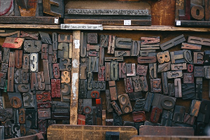

***Typesetters used to align blocks like these for a printing press.***

## **Letter Spacing**

Each letter in a font comes with its own, preset personal space. However, the shape of the letters sometimes creates awkward gaps when we combine them with other letters. We see that when ''r'' and ''n'' turn out looking like a ''m,'' if we don't intentionally increase their spacing. Other letters, like a capital ''A'' and a ''w'' taper inward, so if we leave their spacing alone, they look a little too far apart. The spacing between letters, and the way we sometimes have to adjust it is called **kerning**.

## 

## ***You can see the baseline in this diagram of typesetting lines.***

## **Leading**

Back in the days of the printing press, typesetters would need to create spaces between lines so readers could easily follow the text. Today, we have preprogrammed, and adjustable, line spacing. Back then, they would use a long, rectangular block of lead to create the space. This is why we still call the distance between the **baseline**, found at the bottom of capital letters, of each line of text **leading**. However, we pronounce it like the metal and say ''ledding.''

## **Tracking**

**Tracking** refers to the spacing between groups of characters, which we usually encounter as words. In most cases, we don't have to adjust this too often because the preprogrammed spacing separates the words nicely. However, we sometimes need to adjust the tracking. We never want to end a paragraph with a single word, on the last line, called an **orphan** and we don't want the last line of a paragraph to carry over to a new page all alone, called a **window**. Tracking helps ensure words are spaced just enough to add a few more words to an orphan or a few lines to a window.

However, when we use tracking in a fully justified alignment, where each line begins and ends at the same place, we can get some visual problems. If the extra space between words lines up to create a line of whitespace down the page, we call that a **river**. If we have an awkward and large gap, it's a **puddle**. If the gap is really big and spans multiple lines, we have a **lake**. We can fix that by manually adjusting the tracking, or even adjusting the kerning a bit to fill in the spaces.

## **Why Should You Know This?**

It's not enough to incorporate a word or two in every design. Sometimes, a client will hire you to create an informative design with large passages of text. By understanding the basics of typesetting, especially regarding letter size and spacing, you can includes those text passages in a way that serves your overall message. You don't want sloppy text to ruin the rest of the effect you so carefully constructed.

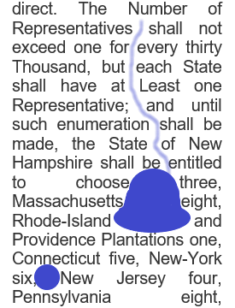

***We want to avoid rivers, puddles, and lakes.***